Project Proposal

On

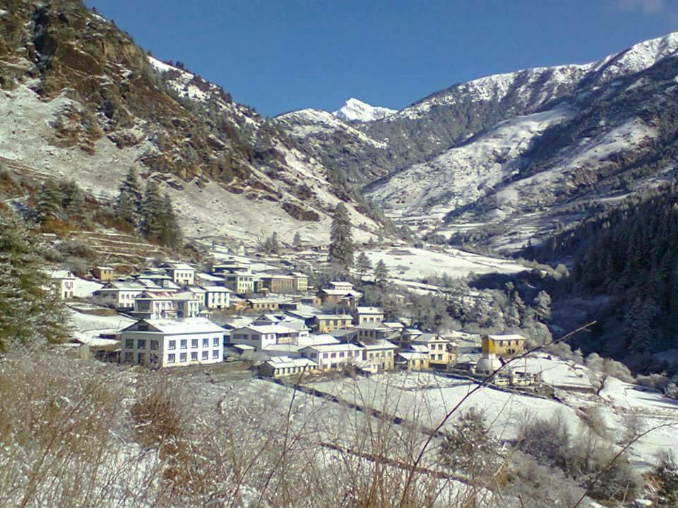**Tour Management System**

Dawa Tenzing Lama

00172886

Email: tenzing0070@gmail.com

Computing Project

Level 5 Diploma in Computing

Softwarica College of IT & E-Commerce

Kathmandu, Nepal

*6th Jan 2019*

Submitted to: Kiran Rana

**Contents**

1. **Introduction**………………………………………………………………..………………………4

1.1 Project Introduction……………………………………………………………………....4

1.2 Justification for project………………………………………………………………..….4

1.2.1 Background of the project…………………………...………………….....….4

1.2.2 Problem statement………………………………………...………………......5

1.3 Description of the project……………………………………….…...………………......5

1.3.1 Features………………………………………………………………………….5

2**. Project Scope**….………………………………………………………….…………….……...….6

2.1 Scope and Limitation of the project……………………………….……….……………6

2.2 Aims and Objectives………………………………………………………………....…...6

3. **Development Methodology**……………………………………………….…………………….8

3.1 Methodology used………………………………………………….………….………....9

3.2 Design Pattern…………………………………………………………...……………….10

3.3 System Architecture………...…………………………………………………………....11

4. **Work Breakdown Structure (WBS) / Scheduling**…………………………………….……..12

4.1 Work Breakdown Structure…………………………………………………………......12

4.2 Milestones……………………………...…………………………………………...……13

4.2 Scheduling / Gantt Chart……………………………………………………………….15

5. **Risk Management**……………………………………………………………………………….17

6. **Configuration Management**………………………………………………………………...…19

7. **Conclusion** ………………………………………………………………………………………21

8. **References**…………………….………………………………………….……………………...22

**List of figures**

Figure 1 Waterfall methodology 8

Figure 2 MVC 10

Figure 3 WBS 12

Figure 4 Scheduling 15

Figure 5 Gantt chart 16

Figure 6 Directory Structure 19

Figure 7 Directory Folders 20

**1. Introduction**

**1.1 Project Introduction**

Tour management is web-based application which is designed to automate the travel process to the customers through online facilities for travelling, easy access to the relevant information and necessary travel booking and arrangement.

The complete information about the project has been highlighted in this project proposal. This application is going to add easiness for those users using such type of application and meet their satisfaction. This application will have various features for fulfilling the user requirement.

**1.2 Justification for project**

**1.2.1 Background of the project**

# Touring is a part of a life as which can sometimes lead to uncertain situation. So, in order to overcome that problem, this project will help users to get all the required information about the schedule and safe routes for their trip.

Solving this problem can uplift the range of tourism to go higher and increase the revenue too. Through this, customers can be able to utilized various benefits and resources such as safe routes, booking, destination information, reviews about the places, environments etc.

The project will be developed using Object Oriented PHP. Different techniques and procedures will be implemented that will enhance the quality of application.

**1.2.2 Problem Statement**

In the current scenario, travelling is kind of hectic because of out dated map, dangerous travel routes, unguided routes, less information of the destination, no proper data records and so on. Similarly, price of the travelling is monopoly accordingly. With the help of the web application, it will be able to remove all the above problem smoothly. Users will be able to get all the required information accordingly, proper safe routes etc. Users will be able to select the desired destination accordingly to the proper budget.

**1.3 Description of the project**

**1.3.1 Features**

* **User Login**

Users are able to make their own account and login into the application to get access all other features.

* Required Information pages:

Users can collect the information of their destination accordingly.

* **Admin Login**

Another part will be the administrator part which will be controlled by admin. Admin can add the destination for their tour.

* **Forum**

Users will be able to access to forum once they make their account.

* **RSS Feed**

It allows users to access to online content in a standardized, computer-readable format.

* **Cookie**

It collects information about how users browse the site.

**2. Project Scope**

**2.1 Scope and Limitation of project**

Since there’s high demand in tourism sector, this system will help to make it more manageable for travelers with full guided information. Following are the few main features that will be included in the project.

1. Detail information about the place to visit.
2. User can select choose destination under various packages.
3. Safe route guidance.

The project will be developed using Object Oriented PHP. Different techniques and procedures will be implemented that will enhance the quality of application. The complete information about the project has been highlighted in this project proposal.

**Limitations**

* Online payment.

**2.2 Aims and Objectives**

**Aims**

* To create user friendly application, to attract more travelers.
* To update the old working system.
* Fast service.
* Online assists.

**Objectives**

* To enable online 24X7 services, highest possible standards to the customers.
* Update about the place information.
* To analyze the total participation of the travelers.
* To create well-organized contents for user satisfaction.
* To develop safe and secure application.

**3. Development Methodology**

**3.1 Methodology used**

It is a framework which is used for planning, structure and control the process of developing an information system. For my project development, I will use waterfall methodology. Since it is easy to manage because of the rigidity of model and sequential design approach.

In order to develop, organize and maintain the information system there are few steps to be taken that will lead the development process efficiently.

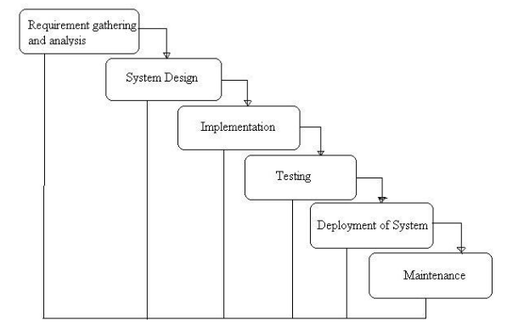

Figure 1Waterfall methodology

Figure: Waterfall methodology

It is very simple methodology of software development. There are few sequential steps which are advanced after the accomplishment of one due to which there is no overlapping during the process. The steps involved in this methodology are:

* **Requirement gathering and analysis**

The first phase involves understanding what need to be design and what is its function, purpose etc.

* **System Design**

The requirement specifications from first phase are studied in this phase and system design is prepared. System Design helps in specifying hardware and system requirements and helps in defining overall system architecture.

* **Implementation**

 With inputs from system design, the system is first established in small programs called units, which are then integrated in the next phase. Each unit is developed and tested for its functionality which is referred to as Unit Testing.

* **Testing**

Testing is performed in order to avoid the problems. All the units developed in the implementation phase are integrated into a system after testing of each unit.

* **Deployment of System**

 Once the functional and non-functional testing is done, the product is deployed in the customer environment or released into the market.

* **Maintenance**

It involves modifications in the system to improve the performance. These modifications arise due to change that are requested by the customer. Client is provided with regular maintenance and support for the developed software.

**3.2 Design Pattern**

Among the various types of design pattern like Prototype pattern, factory pattern, Model View Controller, Singleton pattern etc. I have chosen the Model View Controller (MVC) pattern.

It is an architectural pattern widely used to develop user interfaces that divides an application into three different interconnected parts. This pattern is used to detached application’s concerns. In this pattern the model is known as the central component of the pattern which directly manages the data, logic and rules the application. A view can represent the information of chart diagram, bar chart etc. and the Controller accept the input that convert it to command for view and mode. Following are the reasons to select this pattern:

* Fast development process.
* Change/modification won’t affect the entire model system.
* Supports asynchronous technique.
* Supports multiple views.

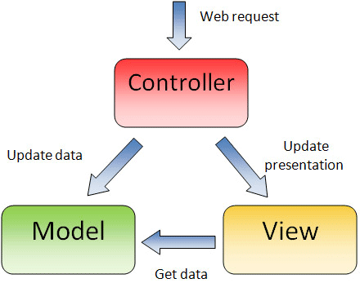

Figure 2MVC

**Controller**: It interacts with model and view.

**Model**: It takes data form the user.

**View**: Provides UI logic for the data.

**3.3 System Architecture**

It is known as the art of constructing and design. In the organization there are various types of architecture for the development of the system. Some of them are N-tier, Two-tier and three- tier architecture.

So, among them I have chosen the three- tier architecture.

Three-tier architecture is a client-server architecture in which the functional process logic, data access, computer data storage and user interface are developed and maintain independent modules on separate platform. The three tiers in this architecture are:

* Presentation tier:
* Application tier:
* Data tier:

I have decided to use three-tier architecture in my project because of the following reasons:

* Easy to apply object-oriented concept
* Easy to update data provider queries.
* Easy to maintain and understand large project and complex project.
* Database Security can be provided at application layer.

**4. Work Breakdown Structure (WBS) / Scheduling**

**4.1 Work Breakdown Structure**

The WBS is the systematic breakdown of project into small parts where each part is related and followed by another. It organizes the teams into manageable so that teams can understand each level of the project. It makes any complex project more manageable. It's used because:

* It assists with accurate project organization.
* It helps in assigning responsibilities.
* It shows the control points and project milestones.
* It allows for more accurate estimation of cost, risk and time.

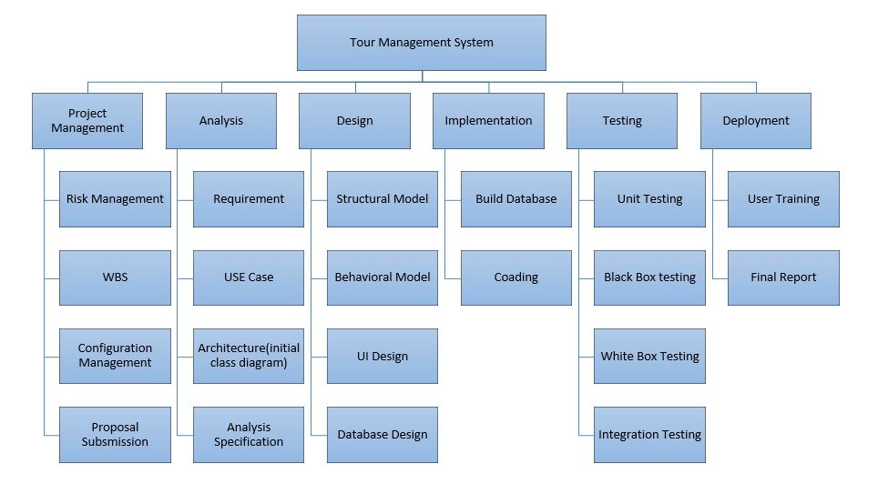

Figure 3 WBS

**4.2 Milestones**

|  |  |
| --- | --- |
| **Milestones** | **Date (MM/DD/YY)** |
| **Project Management**  Risk Management  WBS  Configuration Management  Proposal Submission | **12/21/18-1/3/19**  12/21/18-12/24/18  12/25/18-12/27/18  12/28/18-1/1/19  1/2/19-1/3/19 |
| **Analysis**  Requirement  Use Case  Architecture (Initial Class Diagram)  Analysis specification | **1/4/19-1/27/19**  1/4/19-1/10/19  1/11/19-1/15/19  1/16/19-1/20/19  1/21/19-1/27/19 |
| **Design**  Structural Model  Behavioral Model  UI Design  Database Design | **1/28/19-2/26/19**  1/28/19-2/3/19  2/4/19-2/9/19  2/10/19-2/17/19  2/18/19-2/26/19 |
| **Implementation**  Building Database  Coding | **2/27/19-3/28/19**  2/27/19-3/8/19  3/9/19-3/28/19 |
| **Testing**  Unit Testing  Integration Testing  Blackbox Testing  Whitebox Testing | **3/29/19-4/8/19**  3/29/19-3/30/19  3/31/19-4/2/19  4/3/19-4/5/19  4/6/19-4/8/19 |
| **Deployment**  User Training  Final Report | **4/9/19-4/18/19**  4/9/19-4/14/19  4/15/19-4/18/19 |

**Description of Milestones:**

1. **Project Management (14 days)**

* **Risk Management (4 days)**
* **WBS (3 days)**
* **Configuration Management (5 days)**
* **Proposal Submission (2 days)**

1. **Analysis (24 days)**

* **Requirement (7 days)**
* **Use Case (5 days)**
* **Architecture (Initial Class Diagram) (5 days)**
* **Analysis Specification (7 days)**

1. **Design (30 days)**

* **Structural Model (7 days)**
* **Behavioral Model (6 days)**
* **Structural Behavioral (8 days)**
* **Database Design (9 days)**

1. **Implementation (30 days)**

* **Build Database (10 days)**
* **Coding (20 days)**

1. **Testing (11 days)**

* **Unit Testing (2 days)**
* **Black Testing (3 days)**
* **White Testing (3 days)**
* **Integration (3 days)**

1. **Deployment (10 days)**

* **User Training (6 days)**
* **Final Report (4 days)**

**4.3 Scheduling / Gantt Chart**

The time estimation is done for this project as per the days needed to complete each task. I have estimated total time of 119 days.

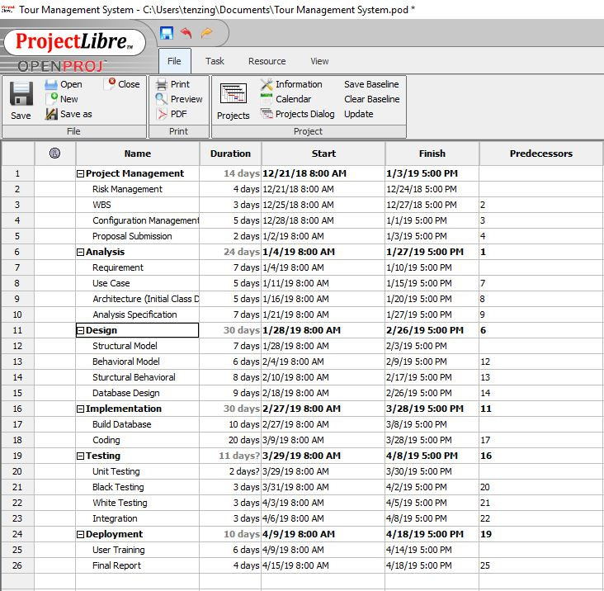

Figure 4 Scheduling

## **Gantt chart**

A Gantt chart is a graphical tool also known as visual presentation of project which shows activities or tasks performed against time the activities are broken down and displayed on a chart which makes it easy to understand and interpret.

The Gantt chart for my project is shown below:

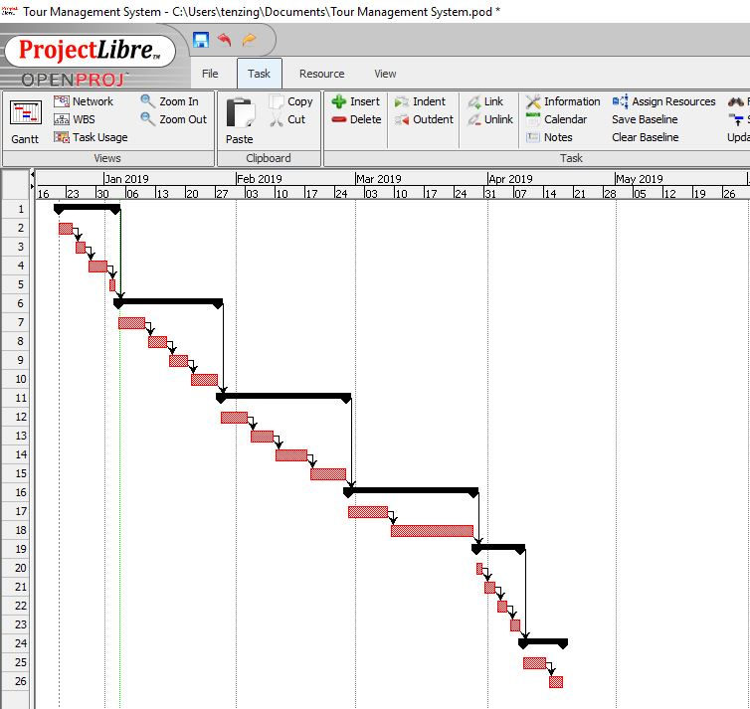

Figure 5 Gantt chart

**5. Risk Management**

In order to identify and avoid the possible risk which may occur during the development of our project is risk management. It will help us to tackle the problem in real time when project should be implemented.

Risks that my project Tour Management System might face while development process are shown below with the values to define its level of attacking the system:

**Impact = Likelihood X Consequence**

|  |  |
| --- | --- |
| Likelihood | Value |
| Low | 1 |
| Medium | 2 |
| High | 3 |

Table: Risk likelihood values table

Risk Consequence values are shown below

|  |  |
| --- | --- |
| Consequence | Value |
| Very low | 1 |
| Low | 2 |
| Medium | 3 |
| High | 4 |
| Very High | 5 |

|  |  |  |  |  |
| --- | --- | --- | --- | --- |
| **Risks** | **Likelihood** | **Consequence** | **Impact** | **Actions** |
| System failure | 1 | 4 | 4 | Prepare backup system and maintenance of a system |
| Hard disk crash | 2 | 4 | 8 | Proper backup multiple server. |
| Impractical budget | 2 | 4 | 8 | Proper planning of the budget required. |
| Hacking | 2 | 2 | 4 | Increase the system security. |
| Virus | 1 | 5 | 5 | Installation of Antivirus software. |
| Change in requirements | 3 | 4 | 12 | Keep Contracts and proof safely |
| Natural disaster | 3 | 4 | 12 | Proper backup and security of the data accordingly. |
| Spam | 2 | 1 | 2 | Block IP addresses for unauthorized users |

Table: Risk management

**6. Configuration Management**

It is the process of developing and maintaining reliability of the performance, functions as well as the physical attributes of any product with its necessities, enterprise and functioning information during its entire life.

It helps to track and keep the detail of the data systematically so that it can be accessed easily when required.

The given figure shows the configuration management of my project.

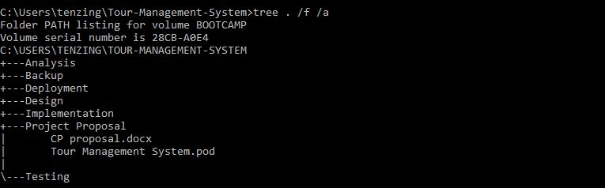

Figure 6 Directory Structure

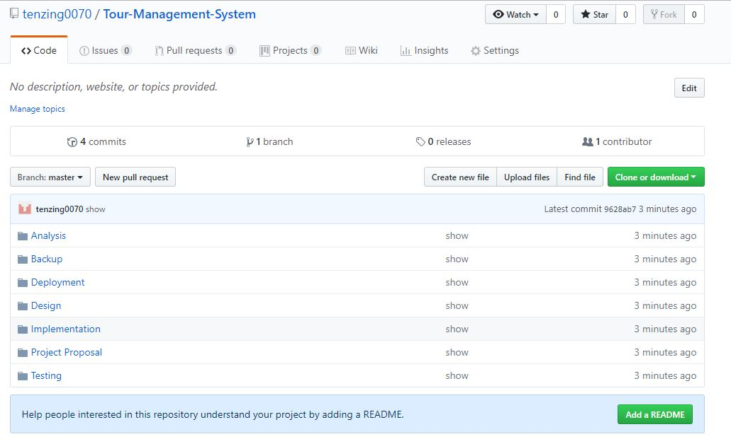

Figure 7 Directory Folders

1. **Conclusion**

This project is developed to help the users by providing all the required information they need for their travelling purpose. It will help to make user to know more about travelling to different proper places, safe routes, destination etc. The application easy to use, efficient, reliable and magnificent for users. This proposal will be the guideline for the project.

1. **References**

* Waterfall Model. (n.d.). Retrieved from Toolsqa: <http://toolsqa.com/software-testing/waterfall-model/>
* Wikipedia.(n.d.).Retrieved from <https://en.wikipedia.org/wiki/Work_breakdown_structure>.
* <http://www.apiumhub.com/tech-blog-barcelona/benefits-of-agile-project-management/>

[Accessed on Dec 20, 2018]

## <https://www.lucidchart.com/blog/agile-software-development-life-cycle>

[Accessed on Dec 20, 2018]